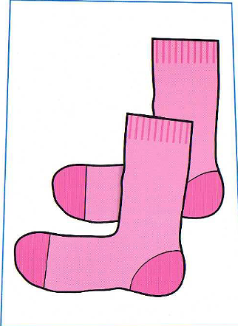  SOCKS | SOCKS | SHORTS
SHORTS | JACKET | JACKET
TROUSERS | TROUSERS | DRESS
DRESS | T-SHIRT | T-SHIRT
SKIRT | SKIRT | JUMPER
JUMPER

