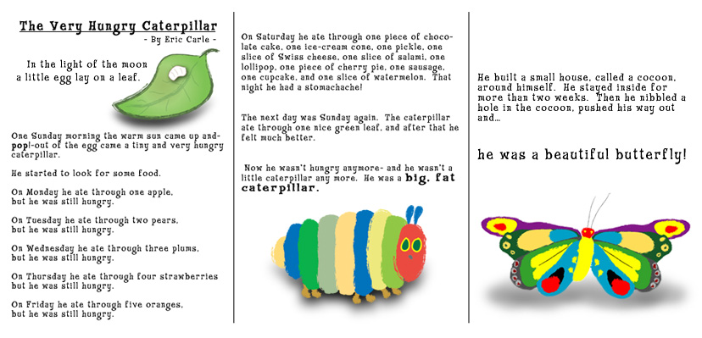

[http://www.shaneeubanks.com/wp-content/plugins/wp-lightbox2/images/loading.gif](http://www.shaneeubanks.com/projects/the-very-hungry-caterpillar/)